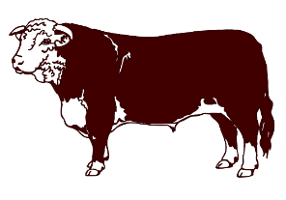
$.79/lb. Processing
$80 Harvest Fee
$25 Quartering Fee

BLACK RIVER MEATS
W11593 Maplehurst lane e.
Withee, wi 54498
715-229-9272
Hanging:
_______ /_______

Customer Information

First Name: ______________ Last Name: __________________ Cull Date:_________
Street Address: _______________________ Phone Number: ____________________
City: _____________ State: _____ Zip: __________ Email:___________________
Beef Cuts

Steaks (circle selection):
- Rib Steak / Ribeye / Prime Rib
(Bone-In) (Boneless) Roast
½” ¾” 1” Thickness
1 2 3 4 per pack
- Sirloin: Bone-In OR Boneless
½” ¾” 1” Thickness
1 2 3 4 per pack
- T-Bone & Porterhouse
OR
New York Strip & Filet Mignon
½” ¾” 1” Thickness
1 2 3 4 per pack
*Animals graded 30 months or older by our USDA inspector will automatically be cut into Boneless Steaks.
Round Steak
(Top Round, Bottom
Round, Eye of Round)
½” ¾” 1” Thickness
(OR Ground Beef)
1 2 3 4 per pack

Roasts:
Off the Hindquarter
- Rump Roast
- Sirloin Tip Roast
Off the Front Quarter
- Chuck Roast
- Arm Roast (Pot Roast)
2-3#’s Other:
Ground Beef:
1 OR 2 lb. packages

Other: (OR Ground Beef)
- Short Ribs
- Brisket
Extras: (at no extra cost)
- Soup Bones
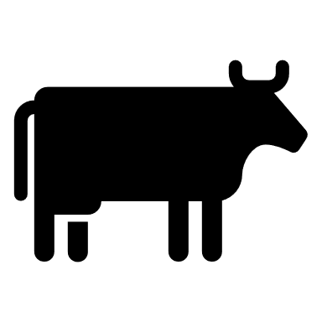
- Tongue
- Heart
- Liver
- Oxtail

